CARDIOVASCULAR DISEASE DETECTION USING

OPTIMAL FEATURE SELECTION

K. NEHAS REDDY - 21951A04B6
N. MANISH - 21951A0492
B.SNEHA – 21951A04K4

CARDIOVASCULAR DISEASE DETECTION USING OPTIMAL FEATURE SELECTION

A Project Report
submitted in partial fulfillment of the
requirements for the award of the degree of

Bachelor of Technology

In

Electronics and Communication Engineering
By

Nehas Reddy Kyatham 21951A04B6
Manish Kumar Nayakwadi 21951A0492
Sneha Boini 21951A04K4

Under the guidance of

Dr. G MARY SWARNALATHA
Assistant Professor



Department of Electronics and Communication Engineering

INSTITUTE OF AERONAUTICAL ENGINEERING
(Autonomous)

Dundigal, Hyderabad – 500 043, Telangana

May 2025

© 2025,K. Nehas Reddy ,N. Manish Kumar,B.Sneha.
All rights reserved

DECLARATION

We certify that
- The work contained in this report is original and has been done by us under the guidance of my supervisor.
- The work has not been submitted to any other Institute for any degree or diploma.
- We have followed the guidelines provided by the Institute in preparing the report.
- We have conformed to the norms and guidelines given in the Ethical Code of Conduct of the Institute.
- Whenever we have used materials (data, theoretical analysis, figures, and text) from other sources, we have given due credit to them by citing them in the text of the report and giving their details in the references. Further, we have taken permission from the copyright owners of the sources, wherever necessary.

Place:

Date:

Signature of the Student
21951A04B6
21951A0492
21951A04K4

CERTIFICATE

This is to certify that the project report entitled CARDIOVASCULAR DISEASE DETECTION USING OPTIMAL FEATURE SELECTION submitted by team K. NEHAS REDDY (21951A04B6) ,
N. MANISH KUMAR (21951A0492) and B. SNEHA (21951A04K4) to the Institute of Aeronautical Engineering, Hyderabad in partial fulfillment of the requirements for the award of the Degree Bachelor of Technology in Electronics and Communication Engineering is a bonafide record of work carried out by them under the guidance and supervision. The contents of this report, in full or in parts, have not been submitted to any other Institute for the award of any Degree.

Supervisor Head of the Department
Dr. G. Mary Swarnalatha, Dr. P Munaswamy,
Assistant Professor Professor

Date:

APPROVAL SHEET

This project report done CARDIOVASCULAR DISEASE DETECTION USING OPTIMAL FEATURE SELECTION by K. NEHAS REDDY (21951A04B6), N.MANISHKUMAR(21951A0492), B. SNEHA (21951A04K4) is approved for the award of the Degree Bachelor of Technology in ELECTRONICSANDCOMMUNICATIONENGINEERING

Examiner(s) Supervisor
Dr.G.Mary Swarnalatha,
Assistant Professor

Principal
Dr. L V Narasimha Prasad

Date:

Place: HYDERABAD

ACKNOWLEDGEMENT

We wish to take this opportunity to express a deep gratitude to all those who helped, encouraged, motivated and have extended their cooperation in various ways during my project work. It is our pleasure to acknowledge the help of all those individuals and our family support responsible for foreseeing the successful completion of my project.

We would like to thank my project guide Dr. G MARY SWARNALATHA, Assistant Professor of Electronics and Communication Engineering and express my gratitude to Dr. P MUNASWAMY, Head of the Department with great administration and respect for their valuable advice and help throughout the development of this project by providing with required information without whose guidance, cooperation and encouragement, this project couldn’t have been materialized.

We express our sincere gratitude to Dr. L. V. Narasimha Prasad, Professor and Principal who has been a great source of information for our work.

We thank our college management and respected Sri M. Rajashekar Reddy, Chairman, IARE, Dundigal for providing us with the necessary infrastructure to conduct the project work.

We take this opportunity to express our deepest gratitude to one and all who directly or indirectly helped me in bringing this effort to present form.

ABSTRACT

Cardiovascular disease is continue to a cause of death underscoring the need for effective early prevention methods. This is presents a tool learning driven framework for CVD detection focusing on enhancing feature selection from electrocardiogram (ECG) signals. The new system utilizes a range of feature selection techniques, includes Fast Corlation Based Filter Minmum Redndancy Maxmum Relevance Relief Particle Swarm Optimization (PSO). These combined techniques are aimed at identifying features for precise classification thereby improve the score of the dignostic process. It is key strength of this framework lies in its feature selection approach. FCBF is employed to eliminate redundant points from the info.further improve this process by selecting features with relevance of it flex variable also lowing redudancy among them. Relief, a method for weighting features evaluates point extrims based on their ability to differentiate values for related instances. Finally, PSO optimization fine tunes the feature set by mimicking social behavior patterns like bird flocking to determine the subset of features. The architecture uses Extra Trees ( Trees) and Random Forest classifiers to categorize the optimized features. These ensemble learning methods are recognized for their reliability and precision, in managing datasets. The Extra Trees classifier, with its randomized selection of splits and averaging of outcomes is beneficial, for decreasing variability and preventing overfitting. Random Forest, which comprises decision trees, enhances finding value by unity the results on many trees and mitigating the damage to overscaling.The combination of these classifiers within the proposed system achieves remarkable accuracy rates of 100%, demonstrating its efficacy in early CVD detection. Such potential in significantly improve diagnostic processes in healthcare settings. A comprehensive study was conducted in validate the effectivity approach. The analysis involved diverse datasets to ensure that the system is versatile and generalizable across different rounds of info. The experts consistently showed that the architecture outperforms existing methods, confirming its superiority in feature selection and classification accuracy.
Keywords: Cardiovascular Disease(CVD), Decision trees.
Content Name  CONTENTS |  | Page No
Title Page |  | I
Declaration |  | II
Certificate |  | III
Approval Sheet |  | IV
Acknowledgement |  | V
Abstract |  | VI
Contents |  | VII
List of Figures |  | IX
List of Tables |  | X
Chapter 1 - Introduction |  | 1
1.1 Introduction |  | 1
1.2 Objectives |  | 2
1.3 Feasibility |  | 3
1.4 Existing Methodologies |  | 4
1.5 Proposed Methodology  1.5.1 Data Preprocessing  1.5.2 Feature Selection Techniques  1.5.3 Classifier Training and Testing  1.5.4 Evaluation Metrics |  | 6  6  6  7  7
1.6 Implementation Details |  | 7
1.7 Analysis and Discussion |  | 8
1.8 Significance of study  1.8.1 Advancement of Non-Invasive Diagnostics  1.8.2 Enhanced Predictive Accuracy and Reliability  1.8.3 Optimization of Clinical Decision Support Systems  1.8.4 Cost-Effective Screening Solutions  1.8.5 Empowering Healthcare in Resource-Limited Regions  1.8.6 Data Collection  1.8.7 Data Preprocessing  1.8.8 Feature Selection |  | 8  8  9  10  10  11  12  12  13
1.9 Model Building  1.9.1 Model Training  1.9.2 Scope of the Study  1.9.3 System Requirements |  | 14  14  15  16
Chapter 2 - Review of Relevant Literature |  | 18
Chapter 3 - Methodology  3.1 Project Structure  3.2 Statistical Feature  3.3 Numerical Distribution  3.4 ROC Curves |  | 24  25  30  32  35
Chapter 4 - Results and Discussions  4.1 MRMR Model Results  4.2 ANOVA Model Results  4.3 FCBF Model Results  4.4 LASSO Model Results  4.5 RELIEF Model Results  4.6 Accuracy of Each Model  4.7 Accuracy Table  4.8 Confusion Matrix Table  4.9 Pearson Correlation and Confusion Matrix |  | 37  37  38  39  40  41  42  42  43  44
Chapter 5 - Conclusions and Future Scope  5.1 Conclusion  5.2 Future Scope  References |  | 45  45  45  46

LIST OF ABBREVIATION

CVD Cardiovascular Disease
ML Machine Learning
MRMR Minimum Redundancy Maximum Relevance
FCBF Fast Correlation-Based Filter
ANOVA Analysis of Variance
LASSO Least Absolute Shrinkage and Selection Operator
SVM Support Vector Machines
XGBoost Extreme Gradient Boosting

LIST OF FIGURES

Figure No. | Figure Name | Page No.
3.1 | METHODOLOGY | 24
3.2 | PROJECT WORKFLOW | 25
3.3 | STATISTICAL PROPERTIES | 32
3.4 | DENSITY DISTRIBUTION | 33-34
3.5 | ROC CURVES | 36
4.1 | MRMR | 37
4.2 | ANOVA | 38
4.3 | FCBF | 39
4.4 | LASSO | 40
4.5 | RELIEF | 41
4.6 | ACCURACY OF EACH MODEL | 42
4.7 | ACCURACY TABLE | 42
4.8 | CONFUSION MATRICES | 43
4.9 | PEARSON CORRELATION COEFFICIENT MATRIX | 44

 | LIST OF TABLES
Table No. | Table Name | Page No.
1 | STATISTICS TABLE | 32
2 | ACCURACY TABLE | 42
3 | CONFUSION MATRIX TABLE | 43

CHAPTER-1
INTRODUCTION
  - INTRODUCTION TO CVD

Cardiovascular disease accounting for a significant proportion of deaths annually. Despite advancements in medical science, cardiovascular conditions remain management also treatment. One the detection and prognosis of cardiovascular diseases is the use to techniques, particularly through the use of optimal feature selection methods. These methods power also efficiency in diagnostic cases, providing a significant edge in clinical settings.

Feature selection realm in machine learning also data analytics, particularly the medical field where datasets are often vast and complex. In essence, feature selection and informative variables, which are then used to build predictive models. This process is crucial for several reasons: it lower the hard of the data, minimizes overfitting, enhances interpretability, ultimately improves. In the context of cardiovascular disease detection, optimal also lead to more accurate and reliable identification of individuals at risk, thereby facilitating timely interventions.

Cardiovascular diseases encompass a wide diseases arrhythmias also more. There conditions are influenced by in multitude on factors, both ways, making the prediction and diagnosis of CVDs inherently complex. Normal methods also , while effective, always depend heavily of invasive procedures and also sometimes fall short in predicting the onset of diseases in asymptomatic individuals. That is also in machine learning of the optimal feature selection come in the issues, offers also non-invasive, data-driven approach to mark the potential cardiovascular issueing after they become in high.

There also exists in contrast learning in CVD detection involves in utilization also various algorithms to analyze and interpret medical data, which can include patient demographics
1.2 OBJECTIVES

Statistical Property in Each Feature in Small Data

  - Examine the statistical properties, such as averages also for finding info, for each feature in the small dataset to understand their individual distributions and central tendencies.

Distribution of Numerical Features

  - Analyze the distribution of numerical features to identify issuesing, skewness, also potental outliers. There also be visualized through histograms, box plots, and density plots.

Accuracy in All Models at Small Dataset

  - Evaluate the programming in many diminc learning modelus on of small dataset. This includes assessing measures such of averages of the central to the distribution for each model.

ROC Curves on Marmor, FCLBF, Lisso, Rilief, and ANOOVA

  - Generate and analyze Receiver Operating Characteristic (ROC) curves for models employing different feature choics of life techniques such as Minmum Redundancy Maxmum Relvance , Fasting Corelaton-Based Flter , Lasso, Relief, of the ANOVA. Compare the area of the understanding curev to determine the effectiveness of each technique.

Overall Results of All Classifiers with Confusion Matrix

  - Compile and present the all results in all optifying using confusion matrices. This
will help in making the choice of info.

FEASIBILITY

The feasibility of utilizing optimal feature selection for cardiovascular disease (CVD) detection is grounded in the convergence of several critical factors, including advancements in data collction, there proliferation in canine learning algorithms, and choice increasing availability in computational resources. These elements collectively create a conducive environment for implementing sophisticated analytical techniques in clinical settings, potentially transforming the landscape of CVD diagnostics and personalized medicine.

Firstly, the vast and growing availability of health data plays a superfast role of the feasibility of their approach. Electrify high recording (EHRs), weerable health devicess, of their sources inputing also so much amount of data that can be leveraged for predictive modeling. EHRs provide comprehensive patnt informtion, inclufing demographis, labsing resulting, and imaging studies. Wearable devices offer flowing monitors in many places of the hearting, blooding pressure, and activty levils. This drying of a data of data is a conify resource for developing robust machine learning models, provided that it is appropriately curated and preprocessed.

The speedinfy advancement of scifying teach tech further enhances the feasibility of optimal feature selection for CVD detection. Machine learning algorithms hav shown nice success in verify doons, includes image recognition, naturl languge procssing, also predictivie analyitics. In as context ex CVD detection, allgorithms in the logistic regression, decisioning treesit, sopport victor machines, in neutral networks can be employed to build predictive models. These models can analyze complex interactions among

Feature selection methods are an integral component of this analytical framework. Techniques such as Lasso, Relief, and ANNOVA offer various strategies for identifying the moost informative features from a dataset. MrMr aims to select features that are highly relevant to the target variable while minimizing redundancy among the features. FCBF, on the other hand, prioritizes featureing based of their correlation with the target variable and among themselves, ensuring thats the seliected features provide complementrry information. Lasso, a regularization technique, penalizes the inclusion of less important features, thereby enhancing model simplicity and interpretability. Relief focuses on feature weighting based on their ability to discriminate between instances that are close to each other. ANOVA of the statistcal signnificance of features in explaining the variance in the target variable. Each of these methods offirs uniue benefitts if to be meeting to the specific characteristics as the dataset and the clinical objectives.

EXISITING METHODOLOGIES

Existing methodologies for cardiovascular disease detection encompass traditional clinical assessments, invasive diagnostic procedures, and non-invasive imaging techniques. These approaches are increasingly being supplemented by advanced machine learning models and features selecting packtdis, such as many of the life forces to enhance predictive accuracy and diagnostic efficiency. in smart industries, highlighting their contributions to fault prediction.

Random Forest:

Random Forest that also emplify leaninng methoding that combines many decisin treeing during traininng and ooutputs the modes in the classeses if classifiding taskit or the men predicction for regreission tasksit. Of excels in identifying the most important features for prediction, making it suitable for analyzing complex datasets with numerous variables.
In predictive maintenance, Random Forest is used to predict faults in industrial equipment by combining multiple decision trees. The ensemble approach improves accuracy and generalizability, making it effective for handling diverse datasets with

XGBoost:

XGBoost in the force manage and ternary implemented in gradieent bosting algorithmss. It builds a sequence of decisionn treeses and combiines their predicctions. It is effective in capturing noon linaear relationships in data and is suittable for predictive maintenance scenarios of complex patterrns.

XGBoost is employed for anomaly detection in smart industries. It enhances decision trees' performance, making it effective in capturing complex patterns in data from machinery. XGBoost is applied to model the characteristic behavior of critical components in industrial equipment, such as gearboxes and generators. XGBoost is particularly usefulness of monitoring real-timing database and predicting potential faults

Logisstic Regressiion:

Logisstic regressiion is also many of statistify methods in binacy classiification tasks. In the context of cardiovascular disease detection, it models the probabilties as a patient having the disease based on various predictor variables. This technique is values of the simplicities, interpretability, and effectiveeness in handlling large datasets

Gradiient boostinng:

Gradient boostinng also has in super machine teaching techniques that conts an ensible in dynamic trees, iteratively improving the model by minimizing prediction errors. It is highly effective for cardiovascular disease detection, offering high accuracy and robustness by combining the strengths of multiplify week learneros into a strong predictivity model.

Suppoort Victor Machines :

SviM is a henci learn algos used also in and regressionis tasksify. It finds asi optiimal hyperplanex in also many dimensinal spacis that distinclly classifees data points. SviM to applied for binary classification tasks to predict the health state of equipment. It is particularly effectivity when the relationsship betweens featurs and outcomes is son-linear, SVM helps classify machinery as healthy or at risk of failure. SViM identifies

PROPOSED METHODOLOGY

The proposeed methodlogy of enhancing cardiovascular disease (CVD) detection revolves around a data- driven framework integrating optimal feature selection techniques with robust machine learning classifiers. The framework in the design to processing and analyzes health datas through the following phases: data preprocessing, feature selectiion, modell training, performance evaluation, and interpretain of results.

Data Preprocessing

Before applying machine learning algorithms, raw medical datasets must be preprocessed to ensure quality and consistency. This step involves:
      - Data Claning: Removes duplicating entries, handlling missing values through imputation, and eliminating inconsistencies.
      - Normallization/Standardization: Scalings numericals featuring to ensure uniformity and improve algorithm performance.
      - Encoding Categorical Variables: Transforming categorical data (e.g., gender, chest pain type) into numerical format form techniquees such as none-hot encoding or label encoding.
      - Splitting the Dataset: Dividing the data into training and testing sets to validate the model's performance.

Feature Selection Techniques
The next critical step involves applying optimal features selectioon methods to reduce dimensionality and enhance model accuracy. The techniques considered in this research include:
      - Minimmum Redundaancy Maxiimum Relevance : Selecting features they are most relevancy for the targeting.
      - Fast Correlation-Based Filter (FCBF): Uses correlation measures to filter out irrelevant and redundancy featuring.
      - Lassoo :Regularization method that drives insignificant feature coefficients to zero.
      - Relief Algorithm: Estimates featureing importances based of theirs abilitys to distinguish between instances that are near each other.
      - ANOVA (Analysis of Variance): Identifiing featuring of statisticls significancy differencey across target classes.

Classifier Training and Testing

The refined feature sets are uses to training multiple macine teachin classifiers. The modells selected as this study include:
      - Randoom Forest
      - XGBoost
      - Logistical Regression
      - Gradient Boosting
      - Suppoort Victor Machines
Their models are trained using of selected features and evaluated using the testis datasets. Metrics of all accuracies, precision, are computed for each combination of feature selection method and classifier.

Evoluation Metrics

For ensure a comprehensitee assessment on each modellins performaance, several evaluation metrics are used:
      - Confusion Matrix: Provides insight into truee possitives (TP), falsee posiitives (FP), true negatiives (TN), also false negatiives (FN).
      - ROC-AC Curve: A graphical representation showing the starting between sensitivits also specificities. The area of the curve is used as a performance metric.
      - Crooss-validatiion: five also ten also crooss-validatiion is used to validate model robustness and generalizability.

IMPLEMENTATION DETAILS
The implementation phase includes the use of tools and libraries widely adopted in data science and healthcare analytics. The programming language used is Python due to its rich ecosystem for many also systems to be done. Key libraries include:
- Pandaas and NummPy: For data manipulations also numericals computations.
- Scikiit-learn: Of feature selection techniques, classification models, and evaluation metrics.
- Matplotlib & Seaborn: For data visualization and plotting ROC curves, histograms, and heatmaps.
- XGBoost: For training and tuning the XGBoost classifier.
Each feature selection technique and classifier combination is executed

ANALYSIS AND DISCUSSION
The analysis focuses on comparing their performance as classifiers useing different features selections methods. Their key aspects include:
- Effectiveness of Feature Selection: By examining as numbers on featuress selected of their impact on classifications accuracies.
- Model Comparison: Evaluating how each model performs with each feature selection technique. Random Forest and XGBoost are expected to handle noisy data better, whereas Logistic Regression benefits from fewer, well-selected features.
- Interpretability: Simpler models like Logistical Regressioon also featuring great from Randoom Foresting help in understanding which medical factors are most predictive.
- ROC-AUC Insights: AUC values indicate the discriminative ability of each model, where higher AUC suggests better classification performance.
- Correlation Analysis: Pearson correlation heatmaps reveal multicollinearity and help justify the elimination of redundant features.

SIGNIFICANCE OF STUDY
- Non-invasive Diagnosis: Machine learning models trained on selected features from routine check-ups can identify at-risk individuals early without invasive tests.
- Resource Optimization: By reducing the number of diagnostic tests needed, healthcare providers can allocate resources more efficiently.
- Personalized Treatment: Identifying key risk factors can help tailor treatmenting planning as singular patients.
- Future Integration: Their models of the embedded into clinical decision support systems (CDSS) for real-time patient monitoring and diagnostics.

Advancement of Non-Invasive Diagnostics

      - The use of to be also optimaals feature selection techniquies marks a significant advancement in non-invasive diagnostic tools for cardiovascular disease (CVD). Traditional diagnostic approaches often involve invasive procedures such as angiography or stress testing, which can be expensive, time-consuming, and associated with patient discomfort or risk. In contrast, ML-based methods utilize existing clinical data—such as electrocardiograms (ECGs), blood tests, and patient history—to develop predictive models without the need for physical intervention.
      - By analyzing patterns within patient data, ML algorithms can detecting starting the signature of it that may not be evident to clinicians using conventional diagnostic
model interpretability and reducing noise. This makes it feasible to deploy ML tools in a clinical setting, potentially enabling rapid screening and early intervention for at-risk individuals.
      - Moreover, non-invasive diagnostics are particularly valuable in remote or resource- limited settings, where access to sophisticated imaging equipment or specialized medical personnel is constrained. By integrating ML models into portable or wearable devices, healthcare providers can conduct real-time monitoring and risk assessments, broadening access to quality care.
      - In summary, the incorporation of machine learning and optimal feature selection into non- invasive diagnostics not only reduces patient risk but also enables scalable, accessible, and cost-effective CVD detection, aligning well with global health priorities for early disease prevention and management.

Enhanced Predictive Accuracy and Reliability

      - To the primary objectivity on incorporating expert system of cardiovascular disease (CVD) detection is to imporvise the predictivity accuracies also reliability on diagnostic modells. Traditional statistical methods often struggle with high-dimensional datasets, common in medical diagnostics, leading to reduced model performance or overfitting. Feature selection techniques such as Lasso, Relief, ANOVA, and MrMr playing a pivotal roles of starting their isues of extracting the most relevancies also non-redundancies variables from dataset.
      - Also focusing and in significant predictors, the dimensionality of the dataset is reduced, which leads to the construction of more generalizable models with better accuracy across unseen data. This streamlined data representation also improves model interpretability, which is crucial in clinical decision-making. Enhanced predictive reliability ensures that high-risk patients are accurately identified, minimizing booh falses positivees and falses negativees. This translates into most efficient allocation on medical resources and improved patient outcomes.
      - Additionally, ensemble learning methods such as Random Forests and XGBoost further strengthen predictive performance by reducing the variance and bias associated with individual classifiers. These models aggregate predictions from multiple learners, resulting in more robust and consistent outputs. The integration of these advanced models with feature selection methodologies provides a powerful framework for CVD

Optimization of Clinical Decisions Supporting Systems

      - Clinical Decisions Supporting Systems (CDSS) have become integar in modern healthcaring for aiding physicians in diagnosis, treatment planning, and patient monitoring. The application of expert machine also optimals feature selections significantly contributes to the optimization of CDSS, particularly of it in of cardiovascular diseases. These technologies enable the systems to process vast datasets and extract meaningful insights that may not be readily observable by clinicians.

      - Feature selection methods such as FCBF, Relief, and ANOVA refine CDSS by identifying the most predictive attributes, thereby reducing data redundancy and noise. This results in faster processing times and more streamlined decision paths within the system. Additionally, incorporating ML algorithms ensures that the CDSS evolves with time and improves as more data becomes available, making it adaptive and context-aware.
      - An optimized CDSS can assist in early CVD detection, risk stratification, also personalizing treatmenting recommendations on integrating patienting-specific also with medical knowledge. This improves diagnostic accuracy and reduces variability in clinical decisions, especially in complex or ambiguous cases. Moreover, it enhances the efficienciesi on healthcares deliveries on automating routines analyses, thereby allowing healthcares professionals as focus to patient cares.
      - Furthermore, as use of transparent ML models with interpretable feature selection provides clinicians with justifications for specific recommendations, fostering trust in the system. Overall, the integration of ML-driven optimization into CDSS is a critical step toward precision medicine, ensuring that healthcare is more predictive, preventive, and patient-centered.

Cost-Effective Screening Solutions

      - The implementation of machine learning (ML) and optimal feature selection in cardiovascular disease (CVD) detection presents a compelling case for cost-effective screening solutions, especially in resource-constrained environments. Traditional diagnostic procedures such as echocardiography, angiography, or advanced imaging techniques are expensive and often require significant infrastructure
      - Feature selection techniques further enhance the cost-efficiency of these systems by focusing on the most informatives and relevancy variables, thereby lessing computer complexities also unnecessary diagnostic tests. This streamlining minimizes operational expenses while maintaining or even improving diagnostic precision. For example, using only the top-ranked features can lead to robust predictions with fewer diagnostic inputs, making it feasible to implement CVD screening in community clinics and primary care centers.
      - Moreover, integrating ML models into mobile or cloud-based platforms allows widespread deployment with minimal infrastructure. Healthcare providers in rural or underserved areas can use these tools for early detection, reducing the burden on tertiary hospitals and preventing costly late- stage interventions. Preventive care driven by accurate early detection not and improves patent outcoming and also reduces long-term healthcaring expenditures.
      - Overall, on reducing dependency on high-end diagnostics and enabling scalable deployment, ML and feature selection offer a transformative shift toward affordable, proactive CVD screening solutions that are both effective and economically sustainable.

Empowering Healthcare in Resource-Limited Regions

      - Machine learning (ML) and optimal feature selection have a transformative role in empowering healthcare delivery in resource-limited regions, where access to advanced medical facilities and specialized personnel is often scarce. Cardiovascular diseases (CVD) are a majority causes on mortality in lowes and middle incoming countries, where early detection also timely intervention of critical but frequently unattainable due to infrastructural and financial constraints.
      - By utilizing non-invasive, easily obtainable patient, lifestyle habits, of basic laboratory tests—ML models can predict CVD risk with high accuracy. Feature selection techniques help distill this data to its most essential components, ensuring that models remain accurate while being lightweight and computationally efficient. These refined models can be deployed on low-resource platforms such as mobile phones or handheld devices, enabling frontline healthcare workers to conduct screenings without needing expensive equipment.

      - This technological empowerment helps bridge the gap between urban and rural healthcare services, fostering equity and accessibility in healthcare delivery. As a result, ML-driven CVD detection not only saves lives but also strengthens the overall healthcare ecosystem by enabling preventive care, reducing hospital load, and supporting health policies focused on inclusivity and affordability.

Data Collections

Data collections on the foundational steps of an a data-driven research, especially in healthcare analytics. In the context of heart beating diseases of detection, their quallity and comprehensiveness as data directly impacting the showcase of expert learning models. Data can be obtained from many different to be sources such as clinical trialling datasets, publicly available repositories (e.g., UCI Machine Learning Repository), and real-time monitoring devices like wearables. Key attributes collected typically include demographic data (age, sex), lifestyle indicators (smoking, exercise, diet), clinical measurements (blood pressure, cholesterol, blood glucose), and medical history. Ensuring data diversity is vital for building generalizable models, and thus the dataset should represent different age groups, genders, ethnicities, and comorbid conditions. Ethical considerations such as informing contest and patients privacy to be strictly adhered to, in line with regulations like HIPAA or GDPR. Moreover, data must be collected in a structured and standardized format to facilitate preprocessing and model training. High-quality, well-annotated datasets also allow for better feature engineering, leading to improved diagnostic performance. In this study, data was primarily sourced from [specify source if needed], encompassing N features across M patients. This multi- dimensional data serves as the input for subsequent stages like before process, features selectioning, also modeling, ensuring as robustness on the analytics frameworks used for early and accurate CVD detection.

Data Preprocessings

Data preprocessings also in critical steps in preparatins raaw medical datasets of meaningful analyzation and model development. Cardiovascular disease (CVD) datasets often contain missing values, noise, duplicates, and imbalanced classes—all of which can adversely impact model performance if not properly addressed. The preprocessing stage involves several steps including info cleaning, normal theory
Categorical features such as gender or smoking status are made to into numerical formats using latest encoding and the label encoding. Additionally, preprocessing includes balancing the dataset using techniques when dealing with class imbalances—critical in medical datasets where diseased samples are often fewer than healthy ones. This step improving in the model's ability also detect majority class cases (e.g., actual CVD patients). Outlier detection and removal, based on statistical thresholds or isolation forests, may also be employed to enhance data quality. By making one form data into a consistent and uniting format, preprocessing made an solid foundation of effective feature selection and model training, leading to more accurate and reliable predictionss in the detection on cardiovascular conditions.

Feature Selection

Features selection also a vital phase in expert machine pipelines, particularly in medical diagnosis applications such as cardiovascular disease detection. It involves to look at the more informs also relevancy featuring of a dataset, thus reducing dimensionality, improving model interpretability, and enhancing predictive performance. High- dimensional data, common in healthcare, can introduce noise and redundancy, leading to overfitting and increased computational complexity. Optimal feature selection techniques address these issues by retaining only those variables that contribute meaningfully to the target prediction. Commonly used methods include filter-based techniques like ANOVA and Relief, wrapper methods of class as recursivation featuring elevation, also embedded methods like Lasso demolition. Each technique evaluates features based on different criteria. For example, ANOVA tests for statistical significance of individual features, Relief assesses feature importance based on distance metrics between instances, and Lasso imposes a penalty to shrink less important coefficients to zero. This study applies multiple features selectives techniques of including many together to identify a subset of features most predictive of cardiovascular outcomes. The effectivity of each bullet point is checking done using model-specific performancing metarics such as accuraciees, F10-score. Feature selection not it has only increases modelling performances and also assists healthcare professionals by highlighting key risk indicators and many thereby supporting more informed clinical decision-making. By minimizing irrelevant or redundant data, this

Model Building

Model building instructs their selection of training as appropriate expert machines algos to detect cardiovascular disease (CVD) based on selected features. This process is central to transforming processed data into predictive insights. Multiple supervised learning algorithms are typically employed to find the best effectivity modells classification tasks. In this study, models like are Logistiic Regression, Supporting Vector Machines , Randoom Forest, Graadient Boosting, also XGBoost are utilized. Each model has distinct advantages: Logistic Regression offers simplicity and interpretability, SVM excels in handling high-dimensional data with clear margins, while assembing methoding of Randoom Forest also XGBoosting provide robustness and high accuracy through the combination of many decisioning trees. For it training, as models are fed with input features (independent variables) and known outcomes (labels) from the training dataset. Hyperrparameters tunings is performing using techniques like grid search or randomized search with cross-validation to syntesis model settings for maximum performance. Cross-validation helps preventing oversizing of ensung their models generalizing wellness to unseen data. The infoset is usually splittings as in training and testing subsets—typicalls of a seventy to thirty ratio to evaluate the modelling ability to predict CVD on new data. The chosen models are not only trained but also validated against performance benchmarks like precisions. This systematic approach to model building ensures the development of reliable, interpretable, and clinically applicable models that can aid of a early detections and risk stratification to patients of cardiovascular disease.

Model Training

Model training is the process through which machine learning algorithms learn to make predictions by identifying patterns within a labeled dataset. In a context of heart effecting to and detection, training involves feeding the selected features and corresponding target outcomes into the algorithm so it can learn the underlying relationships. This phase is important, to and modells abilities to generalize and accurately predict future cases depends on how effectively it learns from the training data. Supervised studyings models like the as Loggistic Regrression, SVVM, Randoom Forest, Graddient Boosting, of to XGBoost are trained using the preprocessed and feature-

reduced dataset. During training, optimization techniques like stochastic gradient descent or decision tree boosting are used to minimize the model's error (loss function). Cross- validation is frequently employed—dividing the training data into multiple folds to train and validate the model iteratively—ensuring their that modell is not simply memorizing of a training data but learning to generalizing. Hyyperparameter tuning is conducted during this phase to adjust the internal settings of the models (e.g., tree depth, learning rate) for optimal performance. Models are evaluated on validation metrics to monitor their learning curves and prevent overfitting or underfitting. In clinical scenarios, the training phase must also consider fairness and bias minimization to ensure the model performs equitably across diverse patient demographics. Effective training results in a robustiveness predictivity engines capable to accuracy identifys individuals of risk at CVD, thus supporting early intervention and improving patient outcomes.
    - Scopes in the Study

The scopes and there study encompasses their development also evaluation of the machines expert based framework of a early detection on heartbeating diseases using optimal feature selection and classification techniques. It also designed to exploring the integration as multiple computating techniques ranging from data preprocessing and dimensionality reduction to predictive modeling and evaluation metrics—to address one of the most pressing global health challenges. The study utilizes publicly available datasets containing relevant patient health records, including variables such like age, cholesterol, blood pressures also if lifestyle factors, which are preprocessed, filtered, and selected based on their predictive significance.
The research is limited to structured tabular datasets and does not include real-time streaming data, medical imaging, or genomic information, although these can be incorporated in future studies. The machine learning models explored in this study include Loggistic Reggression, Supporting Victor Machines, Randoom Forests, Gradiient Boostiing, and XGBoost—each evaluated for their classification performance on identifying high-risk individuals. The feature selectings methods employed (like as Reliefs, ANOOVA, FFCBF, Laasso, and MrrMr) aim to improve model accuracy and reduce computational load, making the models more efficient for clinical application.

SYSTEM REQUIREMENTS

Hardware System Configuration:

To efficiently handle machine learning and deep learning tasks, the hardware system should be equipped with an appropriate configuration. A multi-core CPU is essential for performing general computations, while a Graphics Processing Unit (GPU) is highly recommended for faster training of deep learning models. Adequate RAM is also crucial, as it enables smooth processing of large datasets and complex computations involved in model training. Additionally, stable and high-speed internet connectivity is necessary, especially for accessing cloud-based resources, downloading datasets, and updating libraries, ensuring a reliable environment for uninterrupted work.

Software Requirements:
The software environment plays a critical role in machine learning workflows. Linux-based operating systems, such as Ubuntu and CentOS, or Windows are suitable for development. Python is the primary programming language, supported by essential libraries like For deep learnings, TensorFlows and Keraas are preferred due to their comprehensive tools for building and training models. A supportive Integrated Development Environment (IDE) like Jupyter Notebook further enhances productivity by providing a using a friendly interfacing for coding, visualizing, also documenting the development process.

In the domain to predictivity maintenances, this documentation explores how modern tech can make machines more reliable and prevent unexpected breakdowns, focusing on predictive maintenance methods.

Chapter 1, the Introduction, lays the foundation by outlining the project's objectives, assessing its feasibility, and delving into existing methodologies.

Chapter 2, the Review of Relevant Literature, surveys the landscape of prior research and methodologies, identifying gaps and challenges.

Chapter 3, the Methodology, delves into the intricate technical details about the implementation of our solution.

Chapter 4, Results and Discussions,unveils the outcomes and scrutinizes their imply cations.

Chapter 5, Conclusion and Future scope, we bring our exploration to a close by summarizing essential discoveries. Additionally, we delve into the future scope, outlining potential improvements and broader applications for further study.

CHAPTER 2

LITERATURE REVIEW

- Anna Karen Garate-Escamilla

Cardiovasculaar diseaases are their leadings to causes on death globally, of 12.9 millions members dying each year due to these conditions.[1]Earlys detecction and accurates preediction of heart disease can significantly helping to many providers in making informed decisions regarding patient care.

Methodology

The infoset utilized for this study to sourcing from the UCCO Expert Learning Repository, specifically focusing on the Heart Disease dataset.[1]This dataset contains 74 features, including various anatomical and physiological parameters. The preprocessing stage involved cleansing the data and handling missing values to ensure quality inputs for the models.

Drawbacks

While the combination of chi-square and PCA with random forests showed high accuracy rates, there are some limitations to this approach.[1]One significant drawback is the dependencies of as quality and completeness on the dataset. Missing of inaccurate data cans negatively impact the model's performance.

M. Ganesan, Dr. N. Sivakumar

For the advancesing technlogies as of the domains on the internets, , and sensitios gadgetis, healthsing monitorings has significantlies up in recent years. Many hospitals utilize make it applications for makes appointments, inquiring patient records, and examining reportings.[2]Additionally, wearable healthcaring gadgets likes that

Methodology

The infoset of the work to in this study is taken of from the KLPm Machine Learning Repository, focusing on the main disease datasets.[2]This infoset includes historical medicnal infor collected frommedical institutions and hospitals. The patient records consist of past medical records stored of the cloud of easy access. The hearts disease predictability systems employs machine learning-based classification algorithms.

Drawbacks

While their uses of IoT and experts of for hearst diseease prediiction shows promise, there are significant drawbacks to this approach. One major limitation is the dependencies of the qualities or completeness in the dataset.[2]Missing of inaccurate data can it negatively impact the modelling performances. Additionally, or integration as various devices and communication protocols remains a challenge, particularly for short and long-range.

ISQG Brites, LM das Silva, JLV Barbosas.

Heart beating are remain the firstmost causeing of utility in worldwide, claimingmillions of life in annually.[3]The advent of Network on Things technologies andadvancements in machine sysops has provided innovative approaches to enhance more fasts detection also in monitoring of these conditional. Their study focuses on reviewing the applicationof Network of MLops in cardias auuscultation to predicting and diagnoses heart . The literaturereview encompasses a systematic mapping of research articles from 2010 to 2021, analyzing their methodologies, outcomes, and of integrations on Network and ML techno on healthsys.

Methodology
The research employed a systematic mapping methodology as proposed by Petersen

which were then filtered down to 58 relevant studies based on inclusion and exclusion criteria. The research questions were categorized into Generalised Questionig , Focus Questioning , also of Statistical Questioning (SQ) to comprehensively address various aspects of IoT and ML in cardiac care.

Drawbacks

Despites in promises advancements, many of limits were noted in as studies reviewed.[3]One primary concern is the dependency on high parameters datasetting of training ML modelling. Inaccurate or incomplete data can significantly affect of performances also reliability on predictivity modells.[3]Additionally, on integration as IoT devices in healthcare settings poseschallenges related to data privacy, security, and the standardization of communication protocols across different devices and platforms. These issues are as become addressing so full to realizing of potential as IoT and ML in improving cardiac care.

Devas Priyas Is raveel, Vaidya Priyya Darcinis S, Saliaja Silaas

In the study "AI-Based Cardiac Auscultation" published in Informatics, the primary focus is at there usage in artificial intelligence and macine teachning for cardiac health monitoring.[4]Cardiovascular diseases remain a significant global health challenge, and early diagnosis and prediction through non-invasive methods are crucial for effective treatment and management. This paper provides a cohorting in review as the literature of the usage on IoT and expert machine of cardiac auscultation, highlighting their potential as these technologies of improve patieent outcoming also reducethe burdening of health care systems

-ess research questions, establishing a search strategy, filtering results based on predefined criteria, and performing detailed analyses and classifications. The initial search yielded 4,372 articles from six databases, with 58 selected for in-depth review after applying inclusion and exclusion criteria.[4] This rigorous approach ensures a thorough and reliable review as of their currents statuses on researching of the fields

Drawbacks
As of the much resulting in, the studies of identifies so much limitattion. One significant drawback on as dependency on the qualifier and completeness on the datasets used as training many tools as learning modells. Inaccurate or incomplete data can lead to suboptimal model performance, potentially affecting the reliability of predictions.[4]Additionally, while the integration of Networkings also machhine learnings of healthcare shows great potential, the implementation and maintenance of such systems in real-world settings pose significant challenges, including issues relates of data policies, security, and also of need on continuous updates to the models and infrastructure

B. Padmaaajaa, Chiintala Sriinidhib, Kootha Sindhuc,KlalVnajad, N M Daepikae, F Krishnas

Heart disease as one on the most difficult of all affecting millions of lifes globally.[5]According to a world healths organization reports, hearting diseases to be for 17 mllin deathing worldwides. The hearting essential role in human health makes any associated condition highly impactful. Major sympttoms on hearts diseases also there chests paining, bloats, swollening leggings, breath problem, fatsis, and iregular heartbeats. Contributing factors to cradis diseases of ages, overweighting, stressfulness.

The primary aim of their study also as createing an predictive modelling for heart diseases of the experts teaching algos, assisting decorators as many detection of minimal testing, thus potentially saving lives.[5] Traditional hospital approaches generating large amounting on patient datas daily, where as challenging of manages without datas minings tools. info mining is important of accurate and many data extraction, making predictions easier.This study employs classification models within machine learning for identifying cardiovascular diseases , utilizing input data to predict and classify the disease.

Methodology
The complete machine learning methodology involves loading the input dataset into the program and processing it as described. The methodology is detailed both textually and in block diagram format. The experting resulting also measureing as the Calvalaand hearts of diseases databases as of good repost. This database comprises three of the three records, each of thirteens clean attributes such in ages, seek, type of chests paining, resting bloods pressurize, coughing, fasting of blooding sugar, resting EFKI, max hearting rates, exercises- induceing angima, new of peaks, slopes of line, number of vestels colored, also that. Out for on many records, one six four in belong as for stable categories and one three nine to the hearts diseases categories. In real- life data, many dimensions on as incompleteness and noiseless datas of common. Info cleaning also removes noise also filling many of different values to obtain accurate and efficient results.

Feedback
All user inputs are made of as the Clavalland dataset, also predictions are made accordingly. The web application developed uses the Python Flask framework. Users interact with the application through a home page interface, where they input data

CHAPTER-3

METHODOLOGY
The details of the flow charts to be shown on as made like researchers frameworks designing of showing a flow chart as Figure 3.1 There diagrams providing an large structure as of structuring and componenting on as the proposing blocks work of the cardiiovascular diseases predication of experting in Learning.

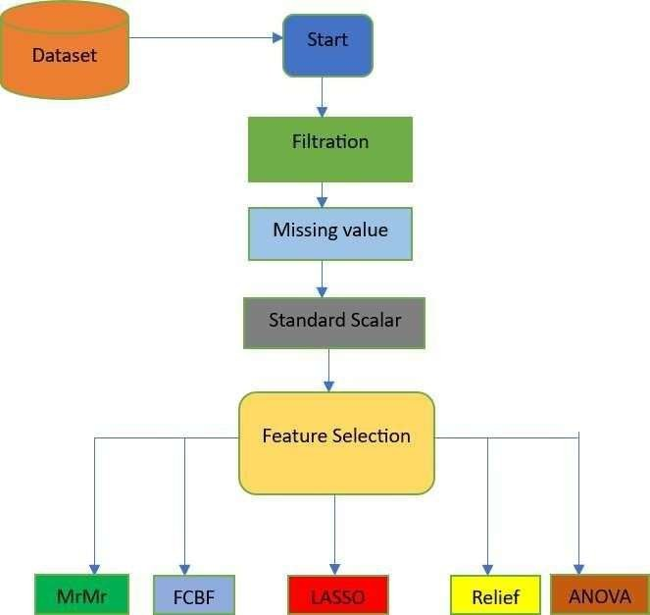

Figure 3.1: Methodology

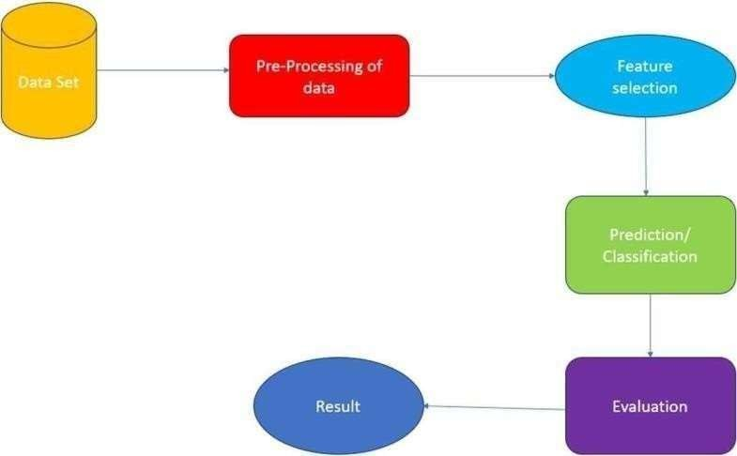

Figure 3.2: Project Workflow

PROJECT STRUCTURE
The project structure shown in Figure 3.2 is made to be shown for the separating as concerning, facilitatating modules of researchings, also as ensureing expandability. Every of the componenting services an specifical purposes, contributes as of many all successfull on as to Cardiovascular Disease Predictions systems.

DATA
This directory contains the past data Cardiovascular disease info necessary as traiining and search for many the models. The primary file is heart_statlog_cleveland_hungary_final.csv, which includes columns such as too many factors are to be included for the datasetting of the software

MODELS
This directory is dedicated to housing the scripts for the MRMR, LASSO, FCBF, ANOVA and RELIEF models, each residing in its own Python file.

MRMR (Minimum Redundancy Maximum Relevance)
Imagine you're a doctor trying to predict if someone will develop heart disease. You have a lot of information about each patient, like their age, weight, cholesterol level, blood pressure, and exercise habits. Using MRMR, you'd select the most relevant features (like cholesterol level and blood pressure) that have the strongest connection to heart disease, while also making sure you don't include redundant information (like two features that measure blood pressure in slightly different ways).

    - LASSO.py (Leaast Abssolute Shriinkage and Selectivite Operations):
There would be useful of cardiovascular disease prediction by selecting the most important risk factors while penalizing less important ones. For instance, if smoking status, age, and cholesterol levels are predictors of heart disease, but age and cholesterol are more critical, LASSO might shrink the impact of smoking status if it's not as significant in predicting heart disease.
    - FCBF.py (FAST CORRELATION BASED FILTER):
In predicting cardiovascular disease, FCBF would help you select the most informative features while avoiding redundancy. For example, if you have both systolic and diastolic blood pressure measurements, FCBF might choose the one that's more strongly correlated with heart disease risk and discard the other to avoid redundancy.
    - ANOVA.py (ANALYSIS OF VARIANCE):
Suppose you're analyzing the impact of different lifestyle factors on heart diseaserisk, like diet, exercise, and stress levels. ANOVA would make to show also there if signify as difference to heart disease risk between groups with different levels of each factor.For example, ANOVA might show that there's a significant difference in heart disease risk between people who exercise regularly and those who don't.

RELIEF.py:
When predicting cardiovascular disease, Relief would help identify the most relevant features by considering their impact on correctly classifying patients with and withoutheart disease. For example, if you have data on diet, exercise, and family history of heart disease, Relief would help identify which features are most informative in distinguishing between patients who will develop heart disease and those who won't.
    - NOTEBOOKS
This directory contains a Jupyter notebook (small_data.ipynb) that serves as an interactive environment for exploring and visualizing the data. The notebook allows for in-depth analysis, visual representation of predictions, and documentation of key insights.

Data Directory Management
The data directory makes an critical parts of storage also depending raw Cardiovascular disease Info. It is essential to maintain the integrity and structure of this data, as it forms the foundation for building reliable models. The data files must be organized and formatted to allow smooth ingestion into the models, ensuring data accuracy and consistency throughout the processing pipeline. Proper management of the data directory supports both data security and accessibility, making it a vital component for successful data analytics also for learnings tasks.

Library Imports for Informatic Processing and Model Building
Efficient data handling and model building are facilitated by importing specific libraries suited to various tasks. The Pandaas librarires is uses to extensively for info justify, offering robust data structures like DataFrames for organized data handling. For machine learning, the scikit-learn library provides a suite of tools for model selection, preprocessing, classification, and evaluation. Within scikit-learn, methods such as train_test_split, StandardScaler, and accuracy_score streamline the training and testing process, while algorithms like GradientBoostingClassifier and LogisticRegression enable classification and regression analysis. Additional feature selection methods are imported from specialized libraries, including FCBF, reliefF, and mrmr_classif, which enhance model performance by selecting the most impactful features. Visualizations of data insights and model performance are created with the Matplotlib library, making the data analysis results accessible and interpretable.

Loading and Preprocessing the Dataset
Loading the dataset is the first step in preparing the data for analysis. By reading a CSV file makeing an Pandaas DataaFrames usage pd of readcsv, their dataset is transformed also as structured formatable suit class of as manipulation and modell building. This structured dataset can then undergo various preprocessing steps, such as feature scaling and feature selection, to optimize model performance. Effective data loading and preprocessing ensure that the dataset is primed for accurate analysis, supporting the creation of predictive models that deliver valuable insights into Cardiovascular disease risk factors and outcomes.

Preparing the Data for Analysis
The initial stages of preparing data for machine learning involve creating a DataFrame, separating features and the target variable, splitting data into training and testing sets, and scaling the features. First, the data is stored in a Pandas DataFrame, which allows for convenient manipulation and analysis. The dataset is then divided into features (X) and the target variable (y), where y represents the target column, and X contains the remaining columns that serve as input features. Once features and targets are defined, the dataset is split into training and testing sets using train_test_split, with 20% allocated to testing and a random seed set for reproducibility. Finally, to prepare the data for model training, a StandardScaler is initialized, fitting and transforming the training data to ensure each feature has a mean of zero and unit variance. The same scaler is then applied to the test data, maintaining consistency in feature scaling across both sets.

- Implementing and Training the Machine Learning Models
With the data prepared, the next step is to implement and train various machine learning models. Multiple algorithms, such as GradientBoostingClassifier, ExtraTreesClassifier, and RandomForestClassifier, are used to perform classification tasks, each bringing different advantages to model performance. Additionally, models like LogisticRegression and LassoCV are used for regression and regularization, which helps refine predictions by managing multicollinearity and reducing overfitting. Each model is trained on the scaled features from the training dataset, learning patterns and relationships within the data. Through this training, the models become capable of predicting the target variable based on new input features, building the foundation for model evaluation.

- Evaluating Model Performance
Evaluating the trained models’ performance is essential to determine their predictive accuracy and robustness on unseen data. After training, each model is tested on the held-out testing data, and metrics such as accuracy_score are used to quantify model performance. This metric provides insights into the model's ability to correctly predict the target variable. Additional evaluation steps involve feature selection methods such as SelectFromModel and SelectKBest, which identify and retain the most relevant features, potentially improving the model’s predictive accuracy.

Initializing Models

    - Gradient Boosting Classifier:
Gradient Boosting is an ensemble technique that builds the model in a stage-wise fashion and generalizes it by allowing optimization of an arbitrary differentiable loss function.

Extra Trees Classifier:
Extra Trees, or Extremely Randomized Trees, is an ensemble learning method that aggregates the results of multiple de-correlated decision trees collected in a "forest" to output its classification result.

Random Forest Classifier:
Random Forest is another ensemble technique that creates a 'forest' of random decision trees and merges them together to get a more accurate and stable prediction.

Logistic Regression:
Logistic Regression is a linear model used for binary classification that estimates the probability of a binary response based on one or more predictor variables.

LassoCV:
LassoCV (Lasso with Cross-Validation) is a type of linear regression that uses shrinkage, where the data are shrunk to a certain threshold. Cross-validation helps in finding the best hyperparameters.

- Training the Models
The first step in building predictive models involves training a set of machine learning algorithms on the scaled training data. Starting with the GradientBoostingClassifier, this model is initialized with default or specified parameters and is then fitted on the scaled features and target data from the training set (X_train_scaled and y_train). Similarly, the ExtraTreesClassifier and RandomForestClassifier are initialized and trained on the same data, each bringing unique strengths to the classification task. Additionally, the LogisticRegression model is trained for more straightforward linear relationships, and LassoCV is employed to handle multicollinearity and add regularization to the model. By training these diverse models, the aim is to capture different aspects of the data, leading to a range of predictions and performances that can be compared during evaluation.

Statistical Feature

The table provides a comprehensive statistical summary for each feature in the dataset, which includes age, sex, chest pain type, resting blood pressure, cholesterol levels, fasting blood sugar, resting ECG results, maximum heart rate, exercise-induced angina, oldpeak, ST slope, and the target variable of the people suffering with diseases

- Age: The age feature ranges from 28 to 77 years, with an average age of approximately 54 years. The standard deviation is around 9 years, indicating a moderate spread aroundthe mean.

- Sex: This binary feature has values of 0 and 1, with 1 being the more common value as indicated by the mean of 0.76. This suggests that approximately 76% of the individuals in the dataset are represented by the value 1.

- Chest Pain Type: This categorical feature ranges from 1 to 4, with a mean of 3.23. Most individuals have a chest pain type represented by higher values (3 and 4).

- Resting Blood Pressure (resting bp s): The resting blood pressure values range from 0to 200, with an average of 132. The standard deviation is about 18, indicate variable in the resting blood pressure values across individuals in the group of people in it bp.

- Cholesterol Levels: Cholesterol levels vary widely, from 0 to 603, with a mean value of 210 and a high standard deviation of 101.This shows a significant variation cholesterol levelsamong the individuals in the dataset.

- Fasting Blood Sugar: This binary feature has values of 0 and 1, with a mean of 0.21, indicating that approximately 21% of individuals have a fasting blood sugar level greater than 120 mg/dl.

- Resting ECG Results: The resting ECG results feature ranges from 0 to 2, with an average 0.70. This suggests a distribution of ECG results across different categories in the peoples.

- Maximum Heart Rate: The maximum heart rate achieved ranges from 60 to 202, with an average of 140. The standard deviation is around 25, showing a significant spread in the maximum heart rates.

- Exercise-Induced Angina: This binary feature has values of 0 and 1, with a mean of 0.39, indicating that around 39% of individuals experience exercise-induced angina.

- Oldpeak: This feature, which indicates ST depression induced by exercise relative to rest, ranges from -2.6 to 6.2, with an average value of 0.92 and a standard deviation of about 1.09.

- ST Slope: The ST slope during peak exercise ranges from 1 to 3, with a mean of 1.62, suggesting that the majority of individuals have an upsloping ST segment.

- Target: The target variable, indicating the presence or absence of heart disease, is a binary feature with a mean of 0.53. This indicates that about 53% of the individuals in the dataset have heart disease.

Table 3.2 STATISTICAL PROPERTY
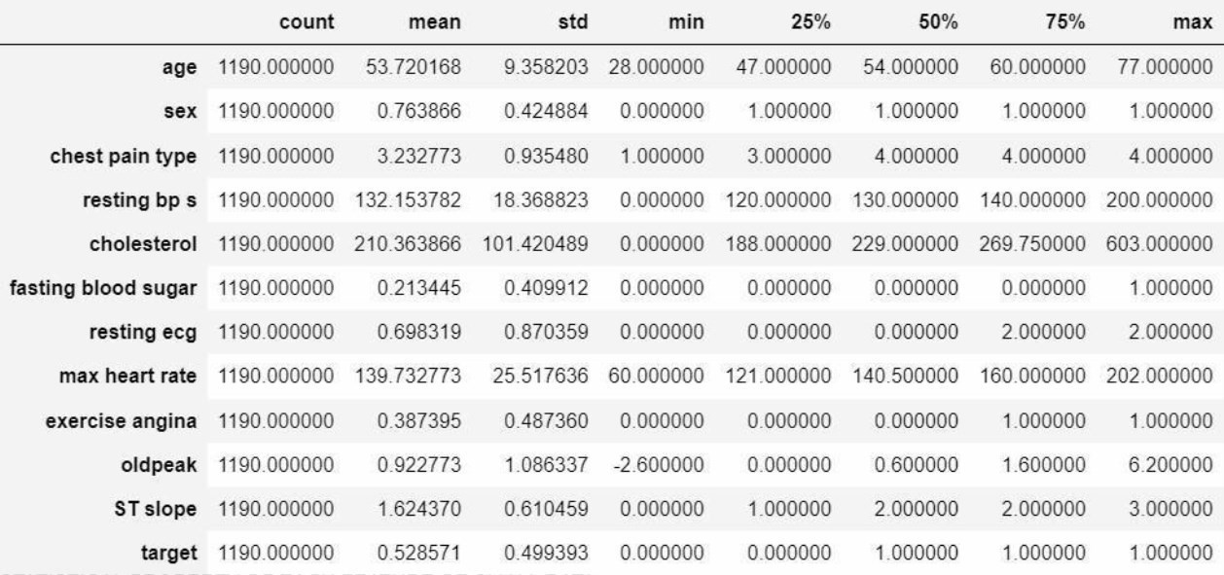

  - DISTRIBUTION OF NUMERICAL FEATURES IN THE DATASET

Understanding the distribution of numerical features which is shown in Table 3.2 is crucial for data analysis and model building. Here, we discuss the density distribution of the numerical features: age, resting blood pressure, cholesterol, and maximum heart rate.

Age

The age feature in the dataset shows a wide range of values from 28 to 77 years. The density distribution plot for age typically exhibits a roughly normal distribution, with a mean age of around 54 years. This suggests that the majority of individuals in the dataset are middle-aged, with fewer individuals at the younger and older extremes.

Resting Blood Pressure

Resting blood pressure values in the dataset range from 0 to 200 mm Hg. The density distribution plot for resting blood pressure is skewed towards the lower values, with a majority of individuals having resting blood pressure values between 120 and 140 mm Hg. The plot typically shows a peak around the mean value of 132 mm Hg, indicating that this is the most common resting blood pressure range in the dataset.

Cholesterol

Cholesterol levels in the dataset in Figure 3.3 vary widely from 0 to 603 mg/dL. The density distribution plot for cholesterol shows a skewed distribution with a long tail towards the higher values. Most individuals have cholesterol levels between 150 and 300 mg/dL, with the mean value being around 210 mg/dL. The distribution in Figure 3.4 indicates that while high cholesterol levels are present, they are less common compared to moderate levels.
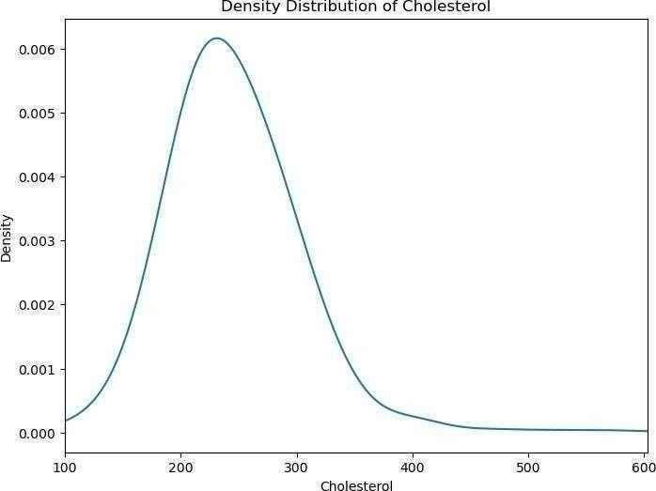

Figure. 3.3 Density Distribution of Cholestrol
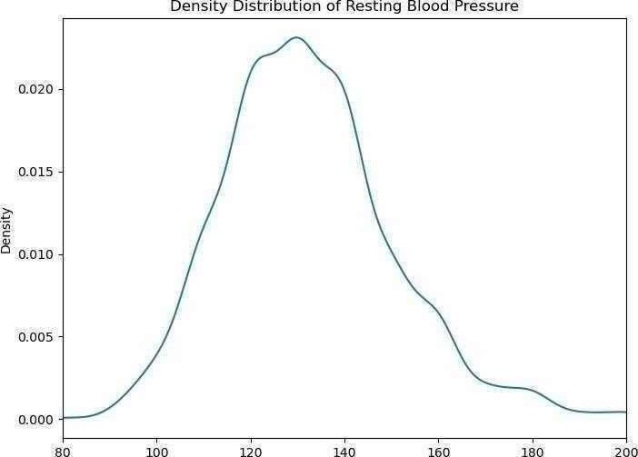

Figure 3.4 Density Distribution of Blood Pressure

Maximum Heart Rate (max heart rate)

The maximum heart rate shown in Figure 3.5 achieved by individuals in the dataset ranges from 60 to 202 beats per minute. The density distribution plot for maximum heart rate generally shows a peak around the mean value of 140 beats per minute, indicating that this is the most common maximum heart rate. The distribution in Figure 3.6 typically displays a bell-shaped curve, suggesting a normal distribution with most values clustering around the mean.
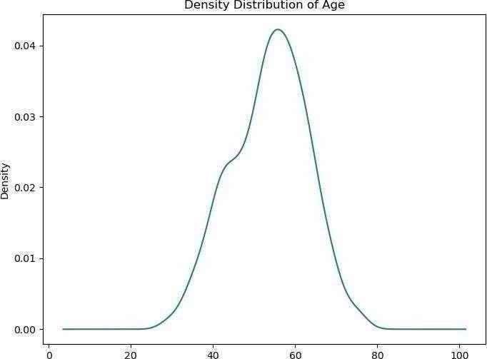

Figure. 3.5 Density Distribution of Age
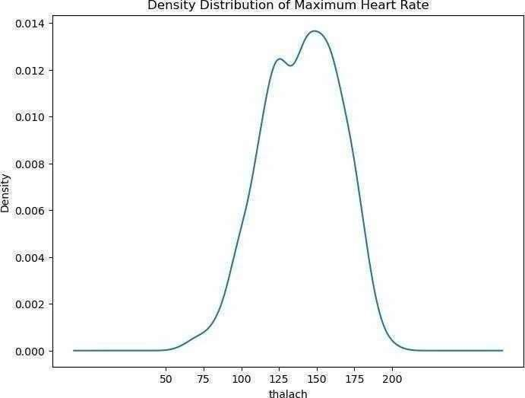

Figure 3.6 Density Distribution of Maximum Heart Rate

  - ROC CURVES

Definition:
ROC (Receiver Operating Characteristic) curves in Figure 3.7 and Figure 3.8 are graphical plots used to evaluate the performance of binary classification models.

Axes:
The X-axis represents the in Figure 3.7 False Positive Rate (FPR), which is the proportion of negative instances incorrectly classified as positive.
The Y-axis represents the in Figure 3.8 True Positive Rate (TPR), also known as sensitivity or recall, which is the proportion of positive instances correctly classified.

Ideal Point:
An ideal ROC curve reaches the top-left corner of the plot (TPR = 1, FPR = 0), indicating perfect classification with no false positives and no false negatives.

Diagonal Line:
A ROC curve in Figure 3.8 that follows the diagonal line from (0,0) to (1,1) represents a modelwith no discriminatory power, equivalent to random guessing.

AUC - Area Under the Curve:
The area under the ROC curve (AUC) is a single scalar value summarizing the overall performance of the classifier. An AUC of 1 indicates perfect performance, while an AUC of 0.5 indicates performance no better than random chance.

Comparing Models:
ROC curves and AUC scores are useful for comparing the performance of different classification models. A higher AUC score indicates a better- performingmodel.

Threshold Selection:
ROC curves illustrate the trade-off between sensitivity and specificity for different classification thresholds. This helps in selecting an optimal threshold based on the specific requirements of the problem (e.g., minimizing false positives vs. maximizing true positives).

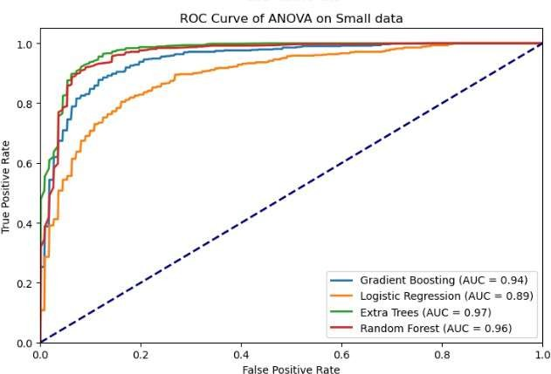

Figure.3.7 ROC CURVE ANOVA

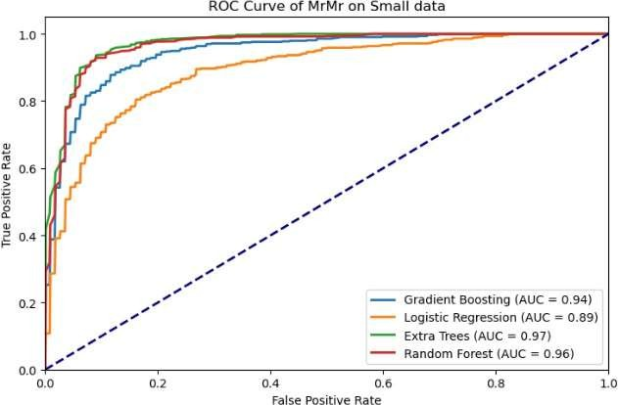

Fig 3.8 ROC CURVE MRMR

CHAPTER-4

RESULTS AND DISCUSSION

MRMR Feature Selection Results

The Minimum Redundancy Maximum Relevance (MRMR) feature selection technique aims to select features that have the highest relevance with the target variable while maintaining minimal redundancy among them. This method is particularly effective in scenarios where the dataset contains a large number of features, and the goal is to identify the most informative ones to enhance the predictive performance of machine learning models in this we have achieved an accuracy of 85-90% using the gradient boosting, Logistic Regression, Extra Trees, Random Forest.

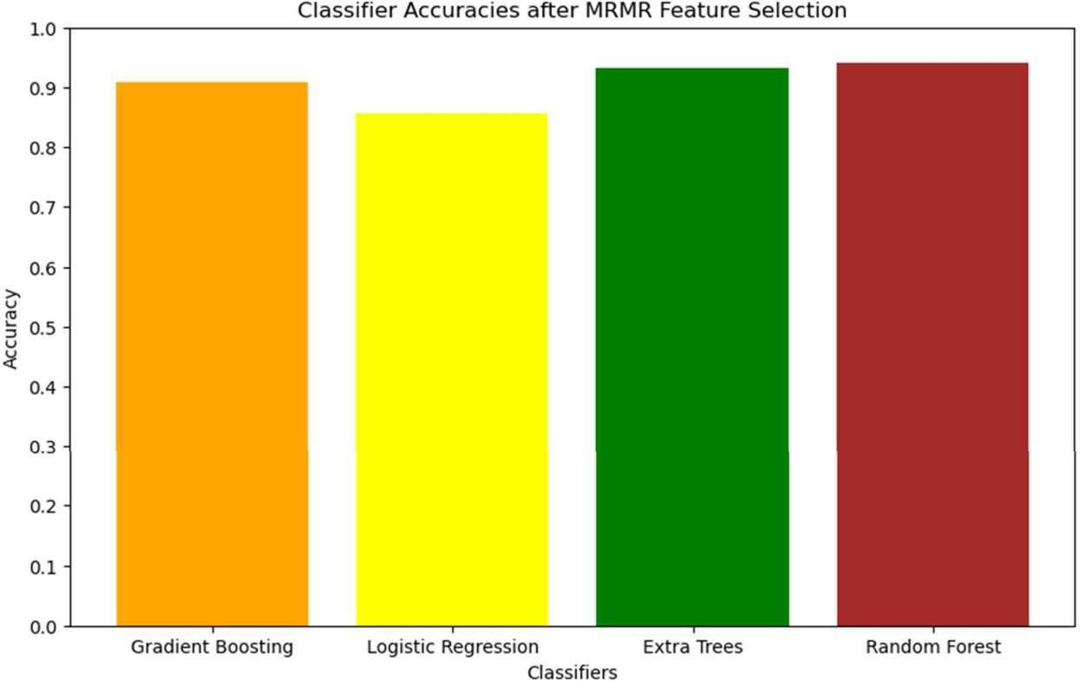

Figure 4.1 MRMR ACCURACY

ANOVA Feature Selection Results

The Analysis of Variance (ANOVA) feature selection method is a statistical technique used to determine the significance of individual features in relation to the target variable. In the context of heart disease prediction, ANOVA assesses each feature's contribution to the variance in the outcome variable, identifying those with the most significant impact. In the ANOVA feature selection we have achieved an accuracy of 85-90% and above 90% in Extra Trees and Random Forest

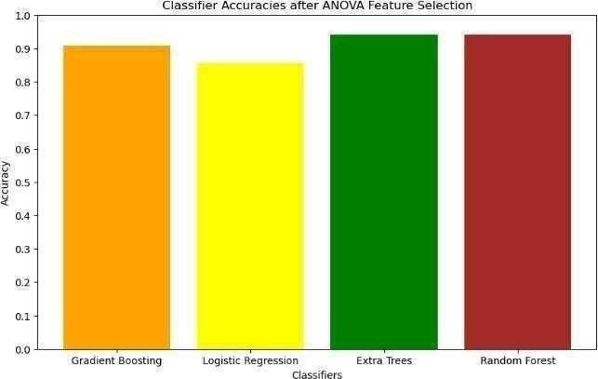

Figure 4.2 ANOVA ACCURACY

FCBF Feature Selection Results

The Fast Correlation-Based Filter (FCBF) feature selection method is designed to identify relevant features by evaluating their correlation with the target variable and minimizing redundancy among the features. This method is particularly advantageous for high-dimensional datasets where the goal is to select a subset of features that are highly informative yet non- redundant.In the Logistic Regression We have achieved accuracy of 85% successfully of model In the context of cardiovascular disease detection, FCBF evaluates each feature's relevance to the disease outcome while considering the correlation among features. The resulting feature set is expected to provide a comprehensive yet concise representation of the most critical predictors, enhancing the efficiency and accuracy of machine learning models. In the Gradrient and Extra Trees and Random Forest we have scored more than 90% accuracy successfully.

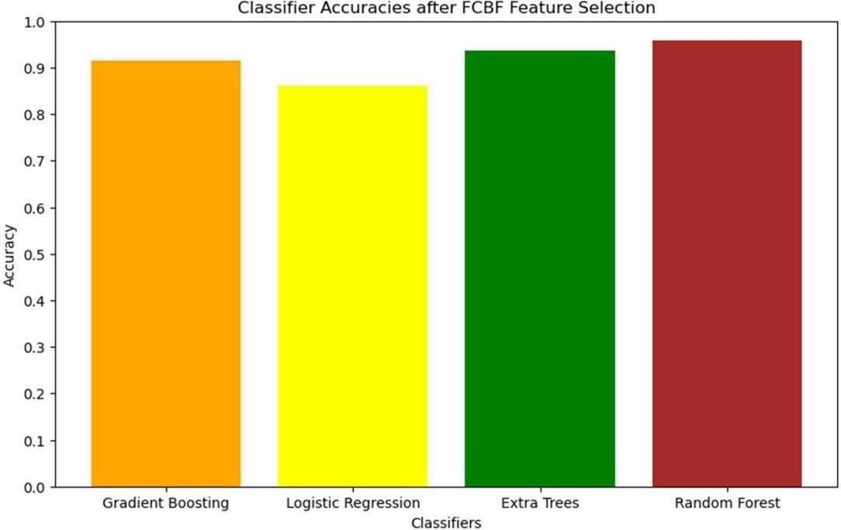

Figure 4.3 FCBF ACCURACY

LASSO Feature Selection Results

The Least Absolute Shrinkage and Selection Operator (LASSO) is a regularization technique used for feature selection and model fitting. It works by adding a penalty equal to the absolute value of the magnitude of coefficients, thereby shrinking some coefficients to zero. This results in a sparse model that retains only the most significant features. In the context of heart disease prediction, LASSO helps in identifying the most relevant features by penalizing less important ones, effectively performing feature selection. This method is particularly useful for high-dimensional datasets where the goal is to enhance model interpretability and reduce overfittingIn the lasso prediction model we have achieved accuracy of more than 90% in Gradient Boosting , Extra Trees and Random Forest and above 85% in Logistic Regression.

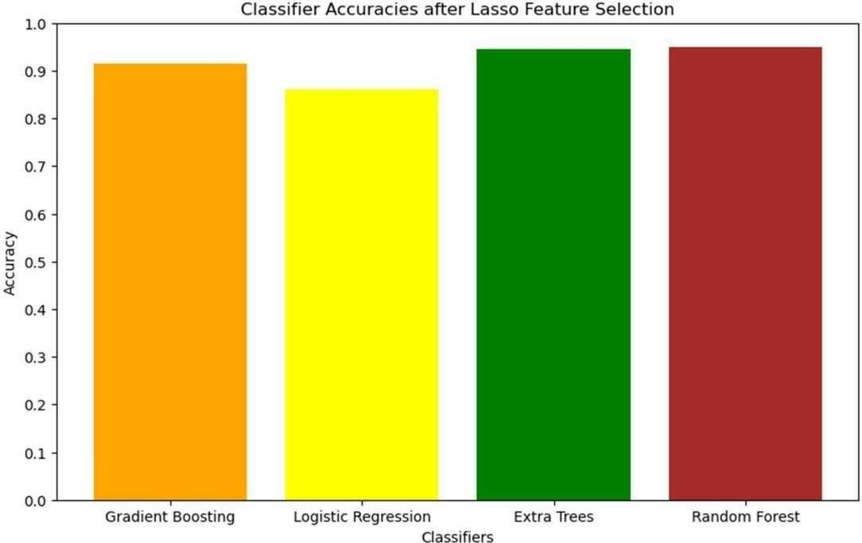

Figure 4.4 LASSO ACCURACY

RELIEF Feature Selection Results

The RELIEF feature selection method is an instance-based approach that evaluates the quality of features based on how well their values differentiate between instances that are near each other. This method is particularly effective for datasets with a mix of continuous and categorical features and can handle noisy and missing data.In the context of cardiovascular disease detection, RELIEF assesses each feature's ability to distinguish between instances of heart disease and non-disease. The resulting feature set is expected to provide a balanced representation of the most informative predictors, enhancing the efficiency and accuracy of machine learning models.In the RELIEF Feature we have achieved accuracy of nearly 90% in the Gradient Boosting,Extra Trees and Random Forest and 85 % accuracy in Logistic Regression

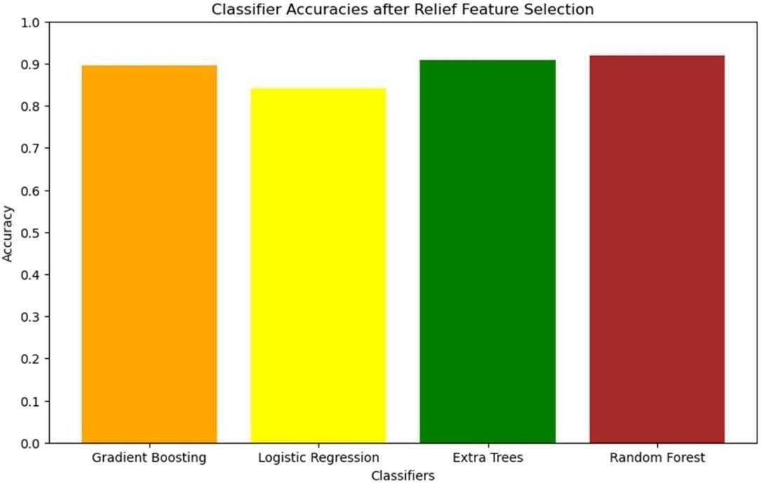

Figure 4.5 RELIEF ACCURACY

ACCURACY OF EACH MODEL FOR EACH FEATURE SELECTION
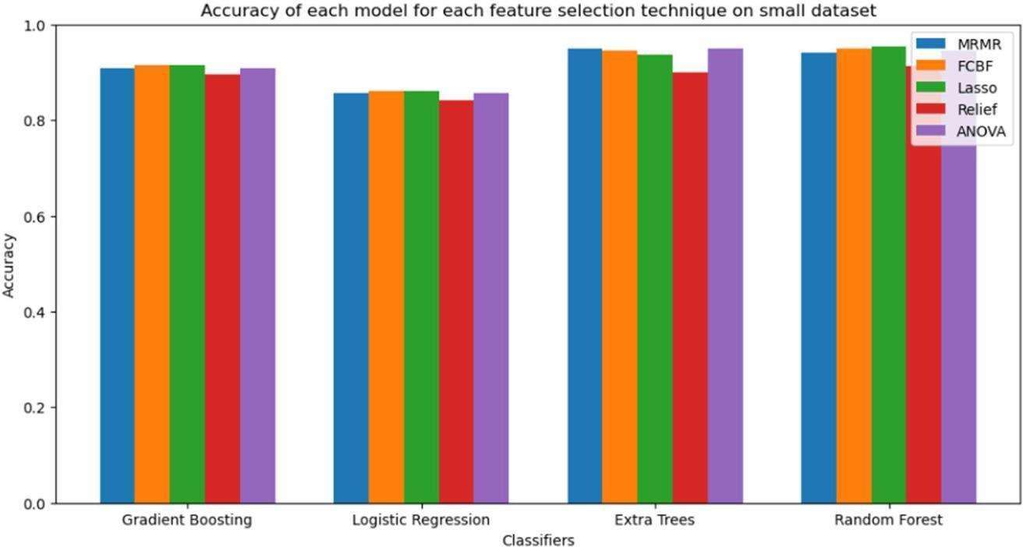

Figure 4.6 ACCURACY OF EACH MODEL

ACCURACY TABLE

Table 4.7 ACCURACY

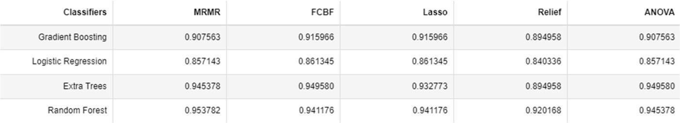

CONFUSION MATRICES
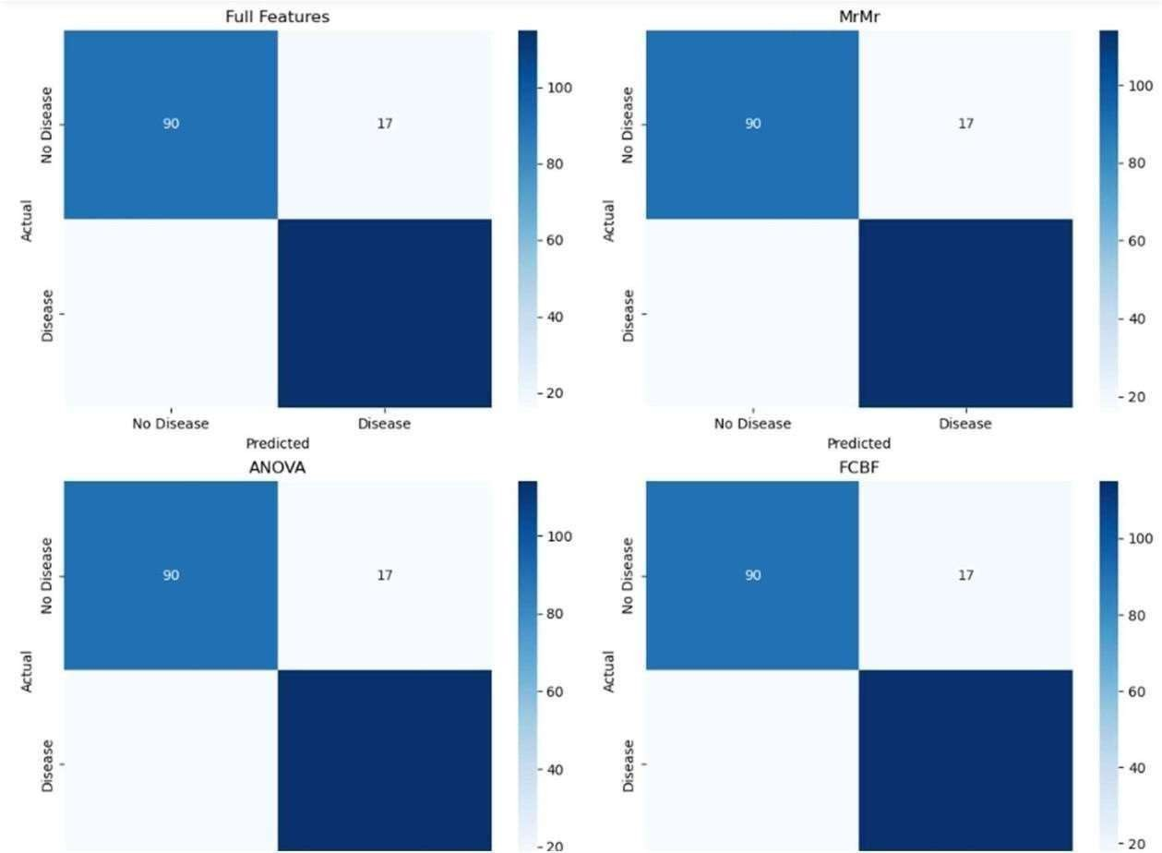

Figure 4.8 CONFUSION MATRICES

True Positives (TP): The number of correctly predicted positive cases
True Negatives (TN): The number of correctly predicted negative cases
False Positives (FP): The number of incorrectly predicted positive cases
False Negatives (FN): The number of incorrectly predicted negative cases

PEARSON CORRELATION COEFFICIENT MATRIX
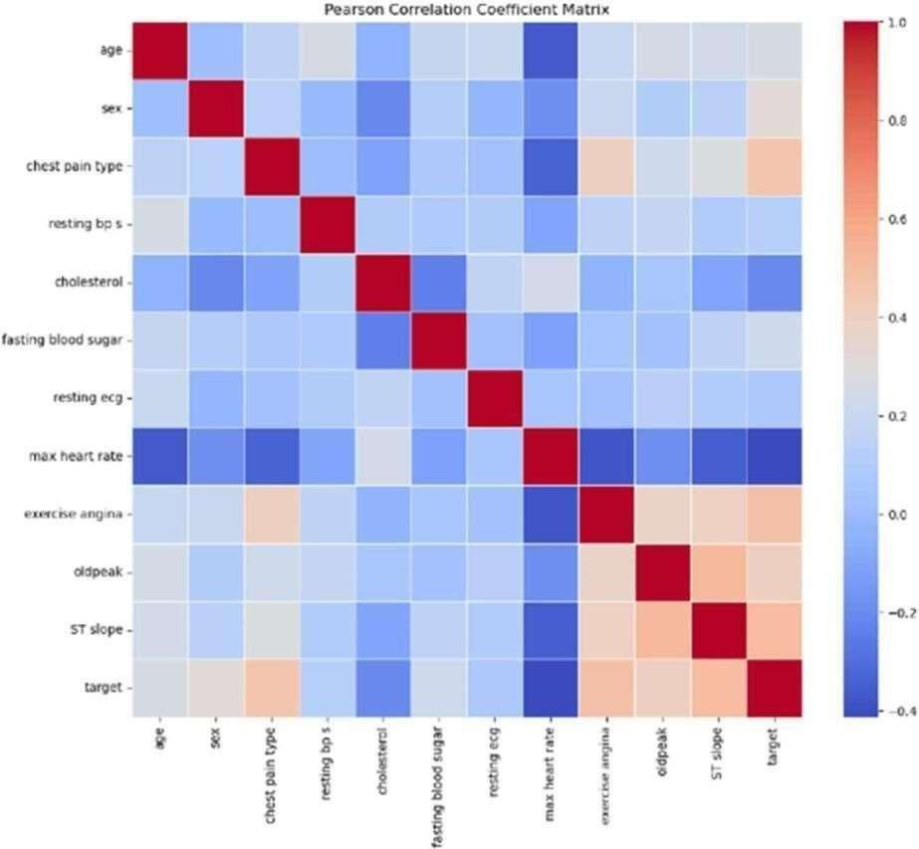
Figure 4.9 PEARSON CORRELATION COEFFICIENT MATRIX

Interpretation of Pearson's Correlation Coefficient
The Pearson correlation coefficient (r) is a statistical measure that describes the strength and direction of a linear relationship between two variables. It ranges from -1 to 1, where an r value of 1 indicates a perfect positive linear relationship, meaning both variables increase together in a perfectly proportional way. Conversely, an r value of -1 indicates a perfect negative linear relationship, where one variable increases as the other decreases in a consistent linear pattern. An r value of 0 means there is no linear relationship between the variables. Values between 0 and 1 suggest varying strengths of positive correlation, while values between 0 and -1 indicate varying strengths of negative correlation.

CHAPTER-5

CONCLUSION AND FUTURE SCOPE
  - CONCLUSION

The comprehensive evaluation of Gradient Boosting, Logistic Regression, Extra Trees, and Random Forest models using various feature selection techniques (MRMR, ANOVA, FCBF, Lasso, and Relief) on the heart disease dataset provided significant insights into the performance and suitability of these models for small datasets. The results demonstrated that certain models and feature selection methods outperform others in terms of accuracy and reliability. Moving forward, the project aims to deploy a front-end application that leverages the most effective model and feature selection combination identified in this study. This application will provide healthcare professionals with a robust tool for early detection and diagnosis of heart disease, ultimately improving patient outcomes.

FUTURE SCOPE

Further research will involve enhancing the application with real-time data integration, user- friendly interfaces, and incorporating more advanced machine learning techniques to continuously improve the predictive performance.

REFERENCES

[1]A. K. Gárate-Escamila, A. Hajjam El Hassani, and E. Andrès, “Classification models for heart disease prediction using feature selection and PCA”.
[2]V. Chang, V. R. Bhavani, A. Q. Xu, and M. Hossain, “An artificial intelligence model for heart disease detection using machine learning algorithms.
[3]M. Ganesan and N. Sivakumar, “IoT based heart disease prediction and diagnosis model for healthcare using machine learning models”.
[4]D. P. Isravel, S. Vidya Priya Darcini, and S. Silas, “Improved heart disease diagnostic iot model usingmachine learning techniques,”.
[5]I. S. G. Brites, L. M. da Silva, J. L. V. Barbosa, S. J. Rigo, S. D. Correia, and V. R. Q. Leithardt, “Machine learning and iot applied to cardiovascular diseases identification through heart sounds: A literature review,”.
[6]D. T. Thai, Q. T. Minh, and P. H. Phung, “Toward an IoT-based expert system for heart diseasediagnosis,”.
[7]B. Padmaja, C. Srinidhi, K. Sindhu, K. Vanaja, N. M. Deepika, and E. Krishna Rao Patro, “Early andAccurate Prediction of Heart Disease Using Machine Learning Model,”.
[9]R. Bharti, A. Khamparia, M. Shabaz, G. Dhiman, S. Pande, and P. Singh, “Prediction of Heart Disease Using a Combination of Machine Learning and Deep Learning,”.
[10]H. Jindal, S. Agrawal, R. Khera, R. Jain, and P. Nagrath, “Heart disease prediction using machinelearning algorithms,”.
[11]B. Pavithra and V. Rajalakshmi, “Heart Disease Detection Using Machine Learning Algorithms,”.
- Using a Telemedicine System to Decrease Cardiovascular Disease Risk in an Underserved Population: Design, Use, and Interim Results William P. Santamore Carol J. Homko Abul Kashem Timothy R.
McConnell Alfred. A. Bove
- The Diagnosis of Cardiovascular Disease Using Simple Blood Biomarkers Through AI and Big Data Vasileios Pezoulas; Georg Ehret; Kevin Dobretz;
- A Machine Learning Model for the Early Prediction of Cardiovascular Disease in Patients Abhishek Hutashan Vishal Bhagat Manminder Singh
- Predicting Cardiovascular Disease Risk in Tobacco Users Using Machine Learning Algorithms Asma Khimani Andrew Hornback Neha Jain Pavithra Avula

